**File Operations**

Write a Java program to write data to an Excel file using Apache POI library.

1. Create a new Excel workbook.

2. Create a new sheet with the name "Sheet1".

3. Write the following data to the sheet: Column headers: Name, Age, Email. Row 1: John Doe, 30, john@test.com. Row 2: Jane Doe, 28, john@test.com. Row 3: Bob Smith, 35, jacky@example.com. Row 4: Swapnil, 37, [swapnil@example.com](mailto:swapnil@example.com).

4. Write a Java program to write data to an Excel file using Apache POI library.

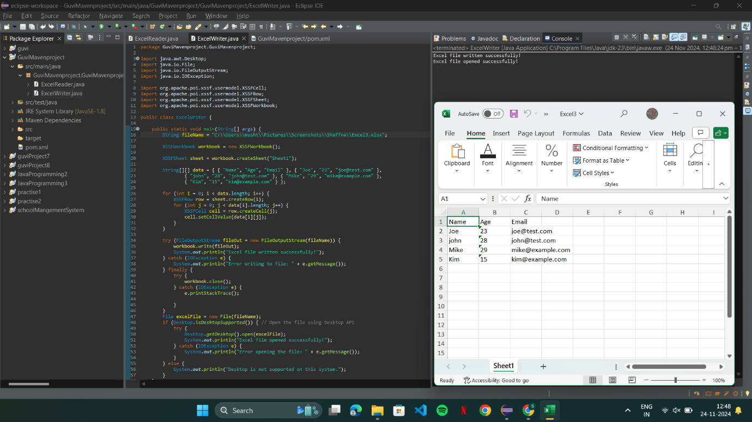

5. Write a Java program to read data from an Excel file using Apache POI library and print it in the console.

